

Student Name: KABURU EVANS MUTHOMI
Admission Number: BSCCS/2024/62210
Course/Class: Bachelors of Science in Computer Science
Unit Code: BIT4138
Unit Name: Advanced Cryptography
Lecturer Name: Michael Nyoro
Semester/Academic Year: May/August 2026

GitHub Repository Link:
https://github.com/mthomikaburu

Contents
Week 5 3
Public Key Cryptography (RSA) 3
Implementation of RSA Encryption and Key Management 3
Fig 1: RSA Key Pair Generation 3
Fig 2: Public Key Encryption Process 4
Fig 3: Private Key Decryption Results 5
Fig 4: Secure Message Transmission 6
Fig 5: RSA Testing and Validation 6
Student Reflection 7

Week 5

Public Key Cryptography (RSA)

Implementation of RSA Encryption and Key Management

Fig 1: RSA Key Pair Generation
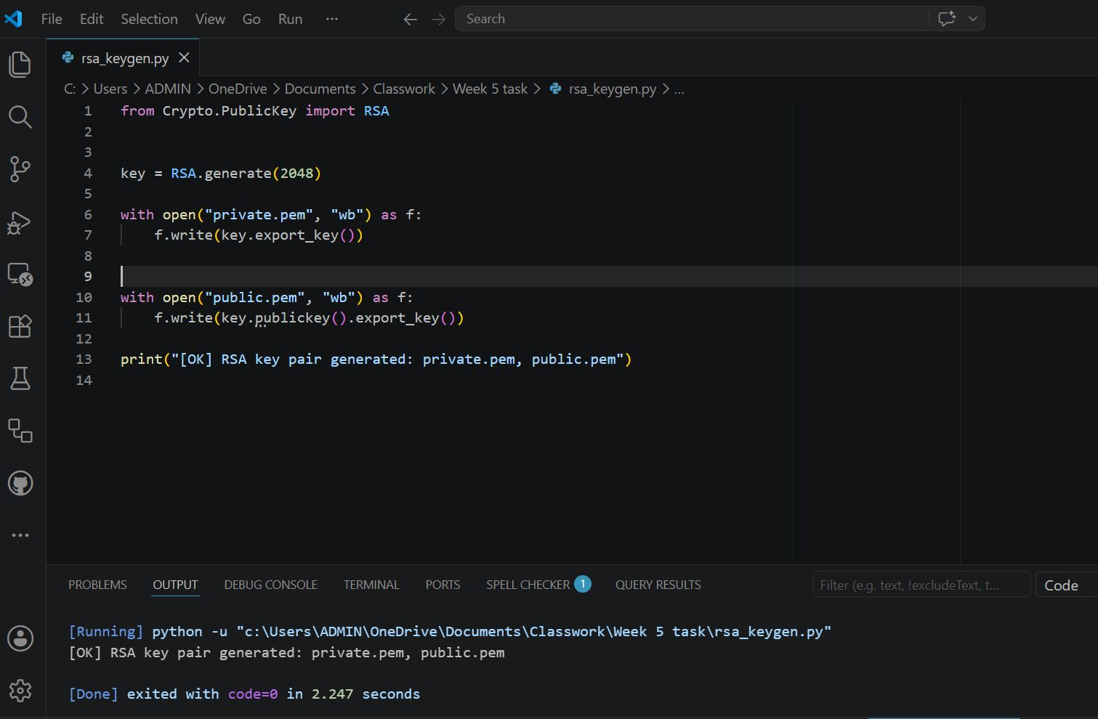

Fig 2: Public Key Encryption Process

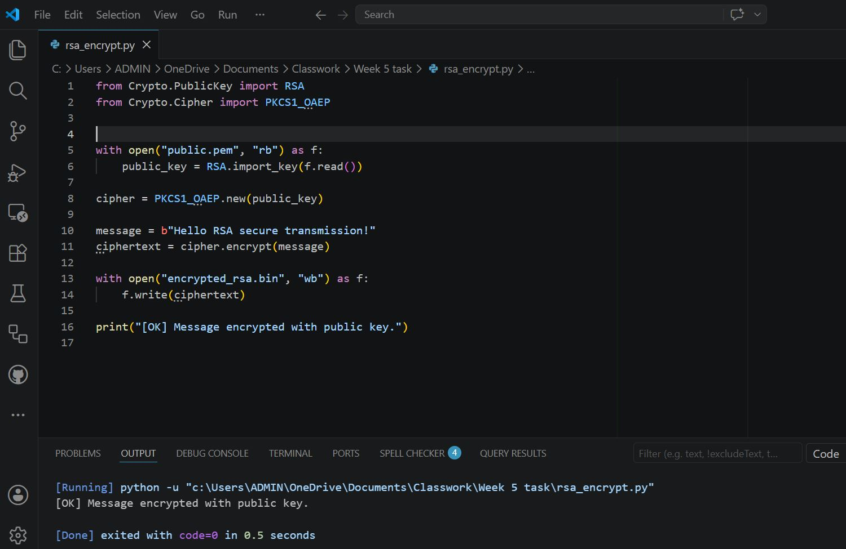

Fig 3: Private Key Decryption Results
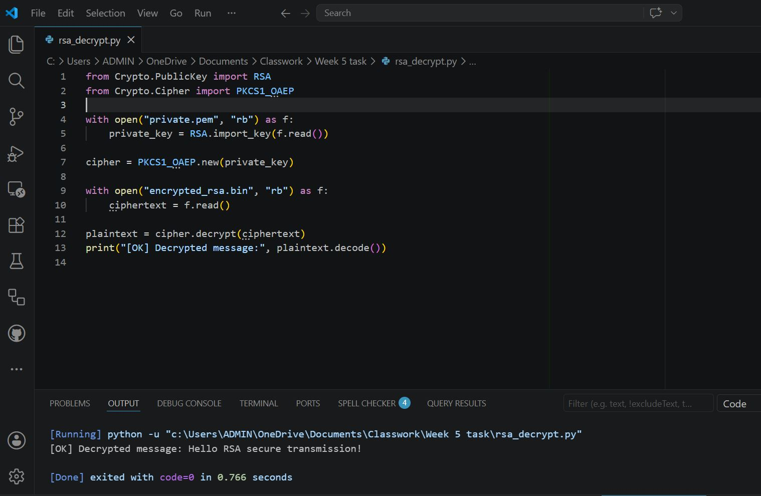

Fig 4: Secure Message Transmission

Encryption output



Decryption output



Fig 5: RSA Testing and Validation

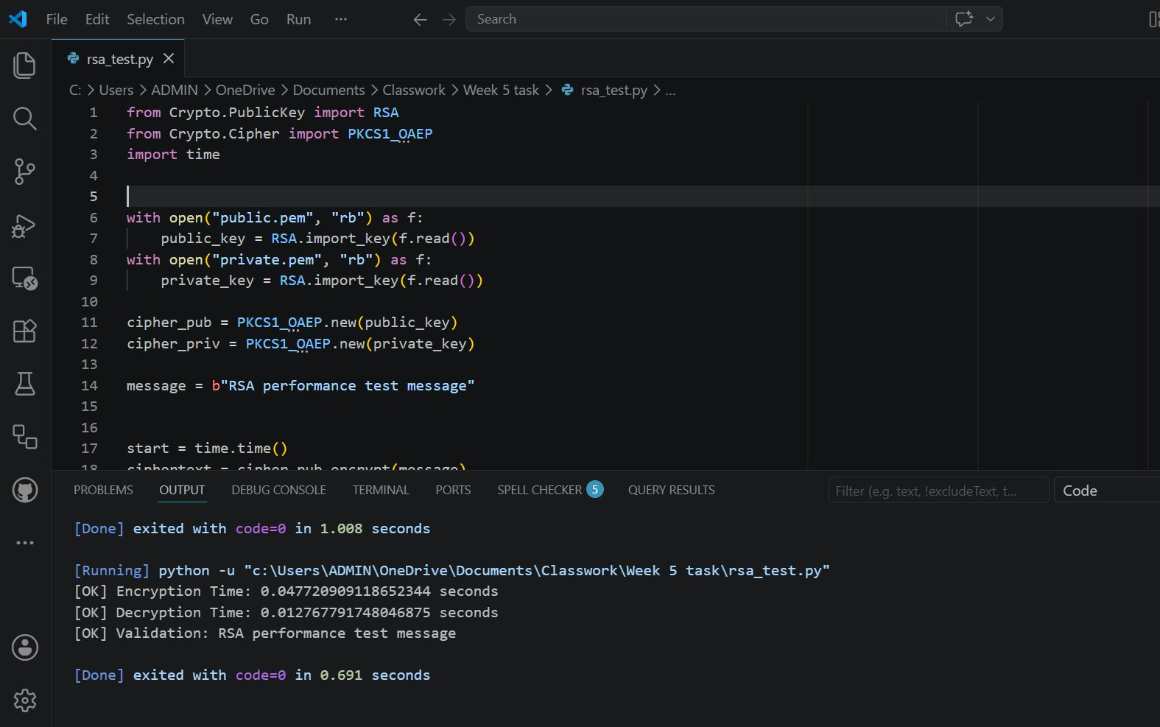

Student Reflection
RSA illustrates asymmetric encryption versus symmetric methods. Public keys encrypt, private keys decrypt, ensuring secure communication. Security advantages include safer key distribution. Testing workflow validated key generation, encryption, decryption, and secure message transmission, confirming RSA’s effectiveness in practice

